Didier Chauveau  Deputy Director  Spectrum Planning and International Affairs Directorate  Agence Nationale des Fréquences  France | 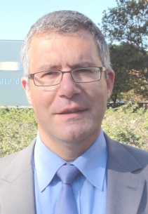

M. Chauveau is Deputy Director of the Spectrum Planning and International Affairs at ANFR. He is involved in the development of national spectrum policy, planning and regulation in France and is a member of number of national committees, chairing few of them. He is currently leading the national project refarming L band 1427-1518 MHz in order to roll out mobile SDL in this band. He joined ANFR by mid-2007 as head of European Affairs.

He is active in number of European committees and is a member of national delegation at WRC. M. Chauveau is deeply involved in European Spectrum Policy and framework. He is co rapporteur of the RSPG activity assessing the impact of the European Electronic Communication Code. He is contributing to RSPG Opinions on 5G. He is the national representative at the Radio Spectrum Committee since 2012. M. Chauveau is an active member of the Project team 1 of CEPT ECC deeply involved in 5G and IMT WRC 19 agenda items. He chaired this group during more than 6 years.

M. Chauveau has been involved in European standardization. Between 1999 and 2006, he has been member of the ETSI Board and, during 2 years, acting as vice chairman of ETSI Board. He is still a member of the ETSI finance committee.

He is graduated from Telecom Paris (2007), Institut National des Télécommunications (INT) (1992) and University of technology (1983).

